**Southern University of Science and Technology**

**Computer Networking Lab Report**

**唐润哲 11710418**

* ***Introduction：***

***#Lab6.1***

Using dash.js to load a dash resource

* + Open “Network” view in ’developer tools’ of browse(such as chrome) to observe
    - Is there any ‘mpd’ files, What’s its name, what is the description of ‘mpd’ in mime
    - Is there any ‘m4s’ files, what’s its related rate, will the files’ ‘rate’ change along with the changing of network condition(especially the bandwidth)
* ***Procedure***

***#Lab6.1***

Using dash.js to load a dash resource and opening developer tools of the brower.

* ***Result：***

***#Lab6.1***

***Q1:***

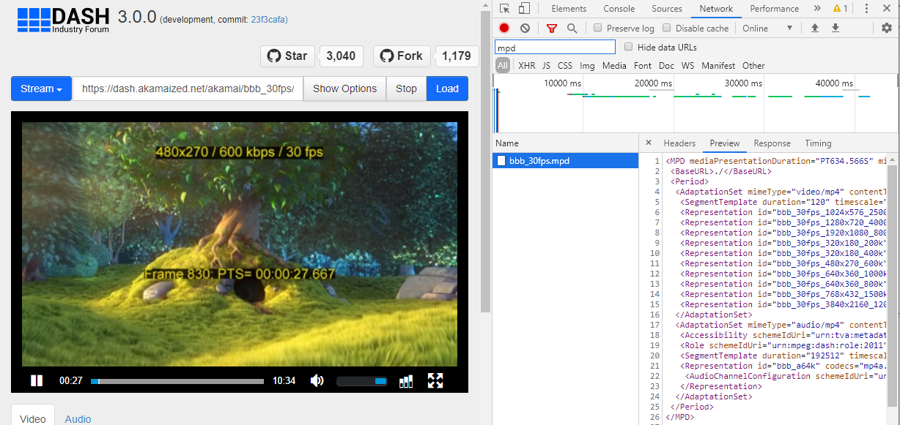

‘mpd’file exists ,its name is bbb_30fps.mpd , its description in mine is video/mp4

***Q2:***

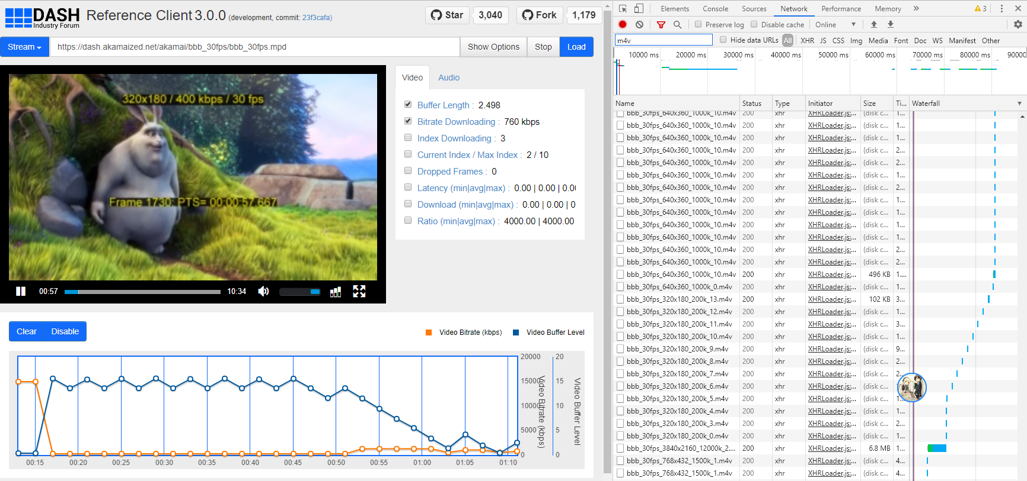

Many‘m4v’files exists. In the picture above, the related rate is 760kbps, and the files’ ‘rate’ change along with the changing of network condition. For example, the picture above is 320*180/400kbps/30fps,rate 760kbps, but the picture below is 768*432/1500kbps/30fps,rate 3134kbps.

